過瘦對身體的影響及正確的飲食

* 太瘦不健康

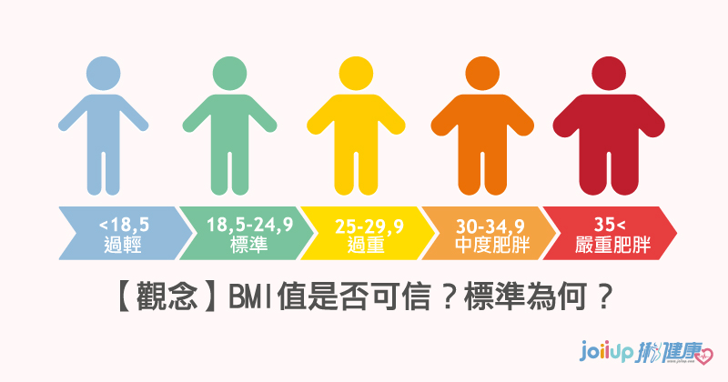

BMI數值小於 ，就是過瘦，就得考慮適當增重，否則可能被以下疾病找上門。

1. 免疫力低下

|  |  |
| --- | --- |
| 感冒 | 呼吸道疾病 |
|  |  |
| 消化不良 | 腸胃道疾病 |
|  |  |

1. 骨質疏鬆

|  |  |  |
| --- | --- | --- |
|  |  |  |
|  |  |

1. 貧血

|  |  |  |  |
| --- | --- | --- | --- |
|  |  |  |  |
|  |  |  |

1. 腎功能受損、血尿

|  |  |
| --- | --- |
|  | 行政院衛生署國民健康局│ 健康九九網站 |

1. 胃下垂

腹痛．腹脹．胃痛．胃脹．胃悶．打嗝．噁心．嘔吐．消化不良．食欲不振．腹瀉．便秘．易有飽脹感

|  |  |  |  |  |
| --- | --- | --- | --- | --- |
| C:\Users\user\AppData\Local\Microsoft\Windows\INetCache\Content.MSO\D473715C.tmp |  | |  |  |
|  | |  |  |
| 1. 健忘 | | | 1. 脫髮 | | |
|  | | |  | | |

* 如何增加體重-

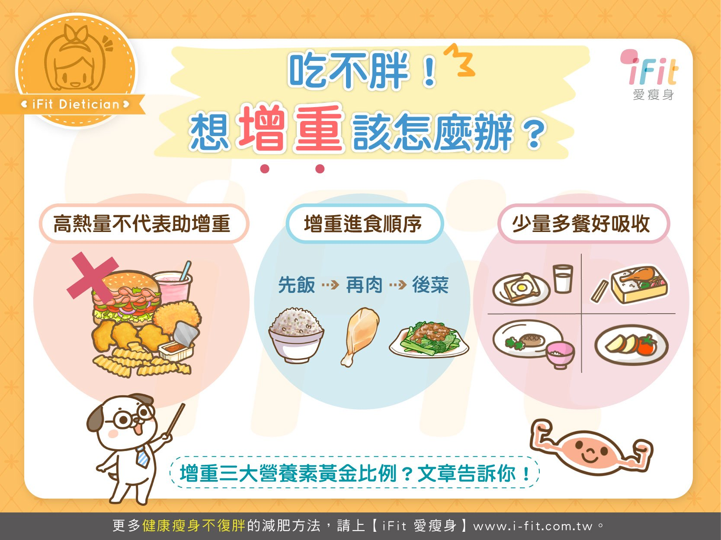

1. 進食順序要改變

|  |  |  |  |  |
| --- | --- | --- | --- | --- |
| 飯 | → | 肉 | → | 菜 |
|  |  |  |

1. 多攝取健康的高脂食物

|  |  |  |
| --- | --- | --- |
|  |  |  |
|  |  |  |

1. 多運動、增加蛋白質攝取

|  |  |  |  |
| --- | --- | --- | --- |
| 多運動 |  |  |  |
| 健康蛋白質 |  |  |  |

|  |  |
| --- | --- |
| [C:\Users\user\AppData\Local\Microsoft\Windows\INetCache\Content.MSO\38FC3DAF.tmp](https://youtu.be/RHnXjgqiWsY) | [呼吸系统卡通](https://youtu.be/14eh7GWZdQI) |
| [消化不良怎麼治| PTT新聞](https://youtu.be/tEOu1g3x6pU) | 幼儿消化系统免抠素材免费下载_觅元素51yuansu.com |

|  |  |  |  |  |
| --- | --- | --- | --- | --- |
| 銀髮族的天敵– 骨質疏鬆（懶人包） - 照護線上 | 疲勞、掉發、頭痛？血紅素不足「貧血」自然找上門：「7個天然方法 ... | C:\Users\user\AppData\Local\Microsoft\Windows\INetCache\Content.MSO\D473715C.tmp | | 脱发卡通图片_脱发卡通素材_脱发卡通高清图片_摄图网图片下载 |
|  | 孩子一找不到東西就著急——面對孩子丟三落四的毛病- 每日頭條 | | |
|  |  |  | | |
|  |  |  |  | |
|  |  |  |  | |
|  |  |  |  | |
|  |  |  |  | |
|  |  |  |  | |

|  |  |  |
| --- | --- | --- |
|  |  |  |

|  |  |  |
| --- | --- | --- |
|  |  |  |
|  |  |  |

|  |  |  |  |
| --- | --- | --- | --- |
|  |  |  |  |